**Calculator Assumed**

**Trigonometric Functions and Applications**

Time: 45 minutes

Total Marks: 45

Your Score: / 45



**Question One: [3, 3, 3, 3, 3 = 15 marks]**

Determine the equation of each of the following trigonometric functions.

1. 

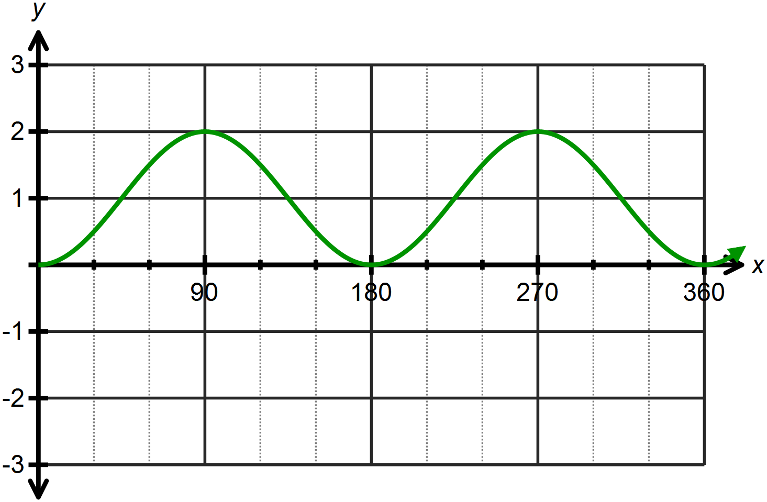

1. 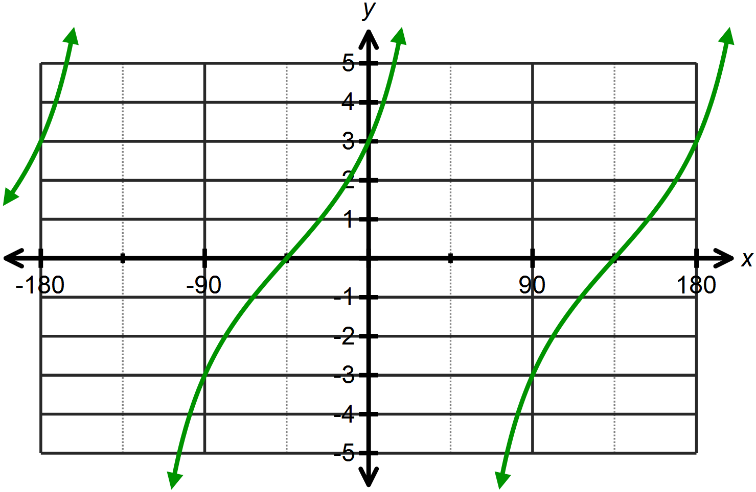
2. 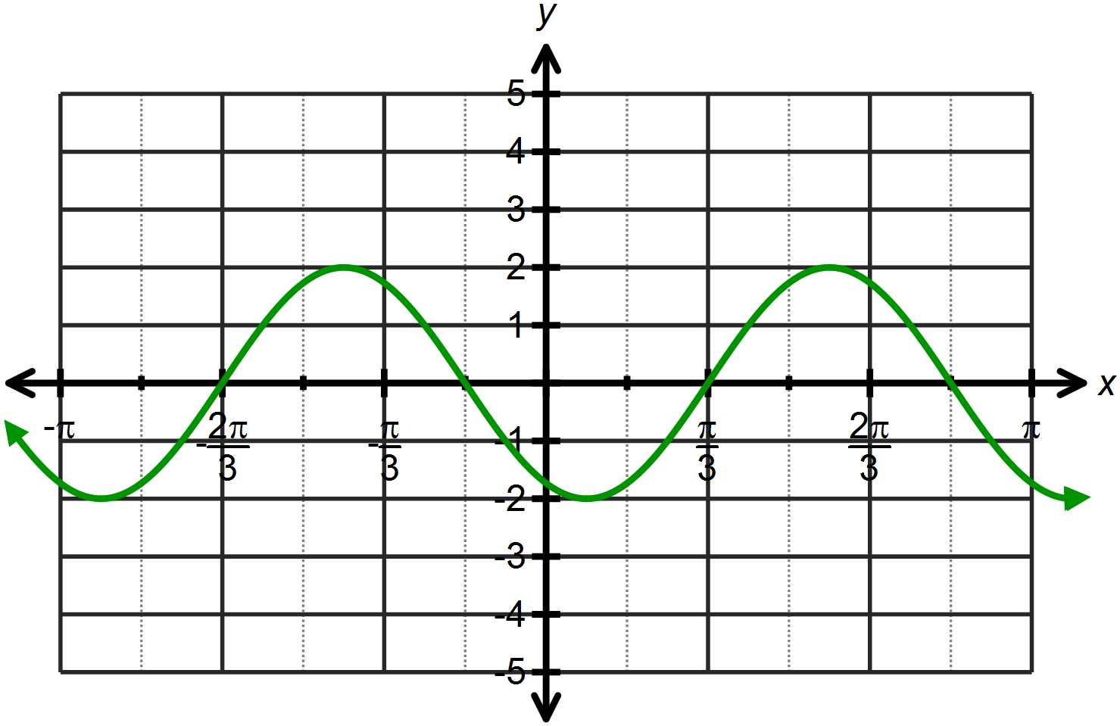
3. 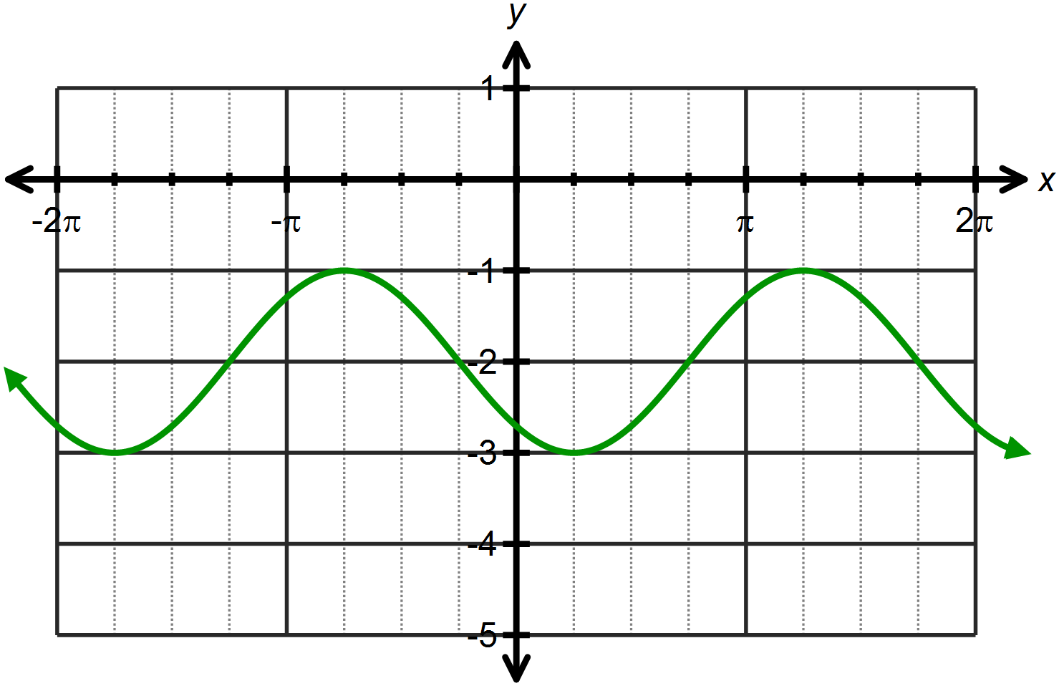

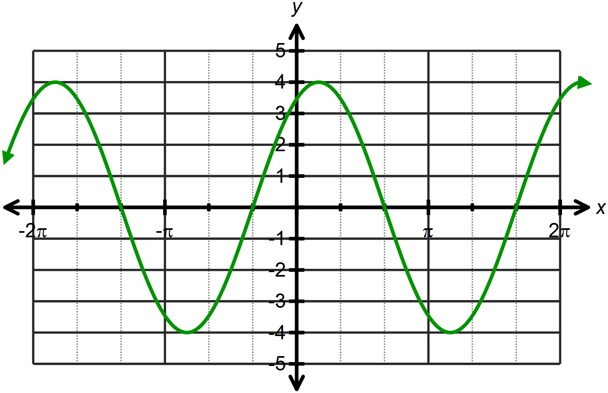

**Question Two: [2, 2, 2, 2, 3 = 11 marks]**

The function is drawn below.

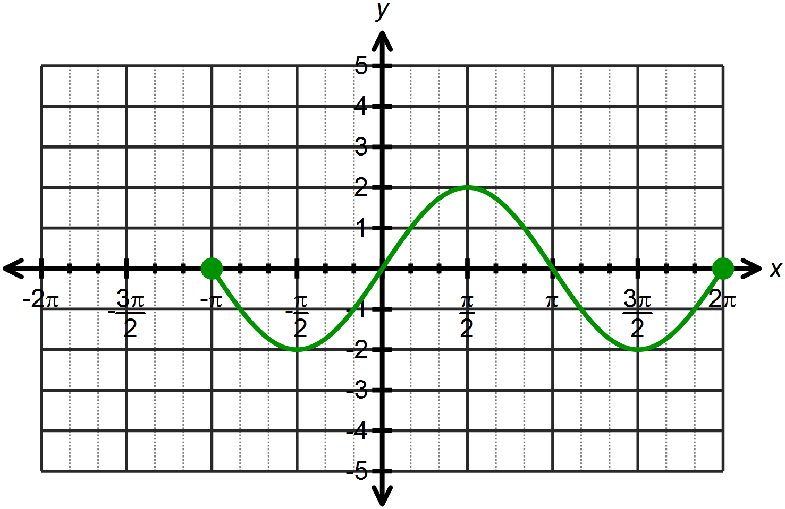

1. State the domain and range of the function drawn.
2. State the roots of the function.
3. State the roots of the function  over the domain 
4. Determine the coordinates of the minimum point(s) of the function over the domain 
5. Sketch  on the axes above, over the domain 

**Question Three: [3 marks]**

In a rural part of Australia, biological scientists are monitoring the populations of wild rabbits and foxes. They have discovered that the population of both species can be modeled by sine functions, where *x* is the time in months since the study began.

The population of foxes is given by: 

The population of rabbits is given by: 

By graphing both functions on your calculator, what do you notice about the population of each species in this rural area?

**Question Four: [1, 2, 3 = 6 marks]**

A satellite is orbiting the earth and its displacement from the equator is modeled by the following function, where north indicates a positive displacement:



At its furthest point north of the equator the satellite is 600 km away. It takes the satellite 1.5 hours to complete one orbit.

1. Determine the value of *A*  in the model above.
2. Determine the value of , the rate or orbit in radians/hour.
3. Hence or otherwise provide a sketch of one cycle of the orbit of this satellite.

**Question Five: [2, 2, 2, 2, 2 =10 marks]**

The temperature of a healthy human body is about 37˚C.

The temperature of a particular healthy individual is monitored over a 24 hour period and the following information is noted.

Their maximum temperature was 37.1˚C at 11 am.

Their minimum temperature was 36.7˚C at 11 pm.

The temperature of their body can be modeled by:

 where *T* is temperature in ˚C and *t* is the time in hours past midnight.

1. Determine the values of *A* and *B* in the equation.
2. If there is only one maximum and one minimum per day, determine the length of one cycle, and hence the value of *w*.
3. Determine the value of α and hence the equation modeling the temperature for this individual.
4. Over which intervals are the temperatures above 36.8˚C?
5. Express the temperature of this individual as a sine function.

**SOLUTIONS**

**Calculator Assumed**

**Trigonometric Functions and Applications**

Time: 45 minutes

Total Marks: 45

Your Score: / 45



**Question One: [3, 3, 3, 3, 3 = 15 marks] NOTE: Other solutions possible**

Determine the equation of each of the following trigonometric functions.



1.  





1. 
2. 
3. 



1. 



**Question Two: [2, 2, 2, 2, 3 = 11 marks]**

The function is drawn below.

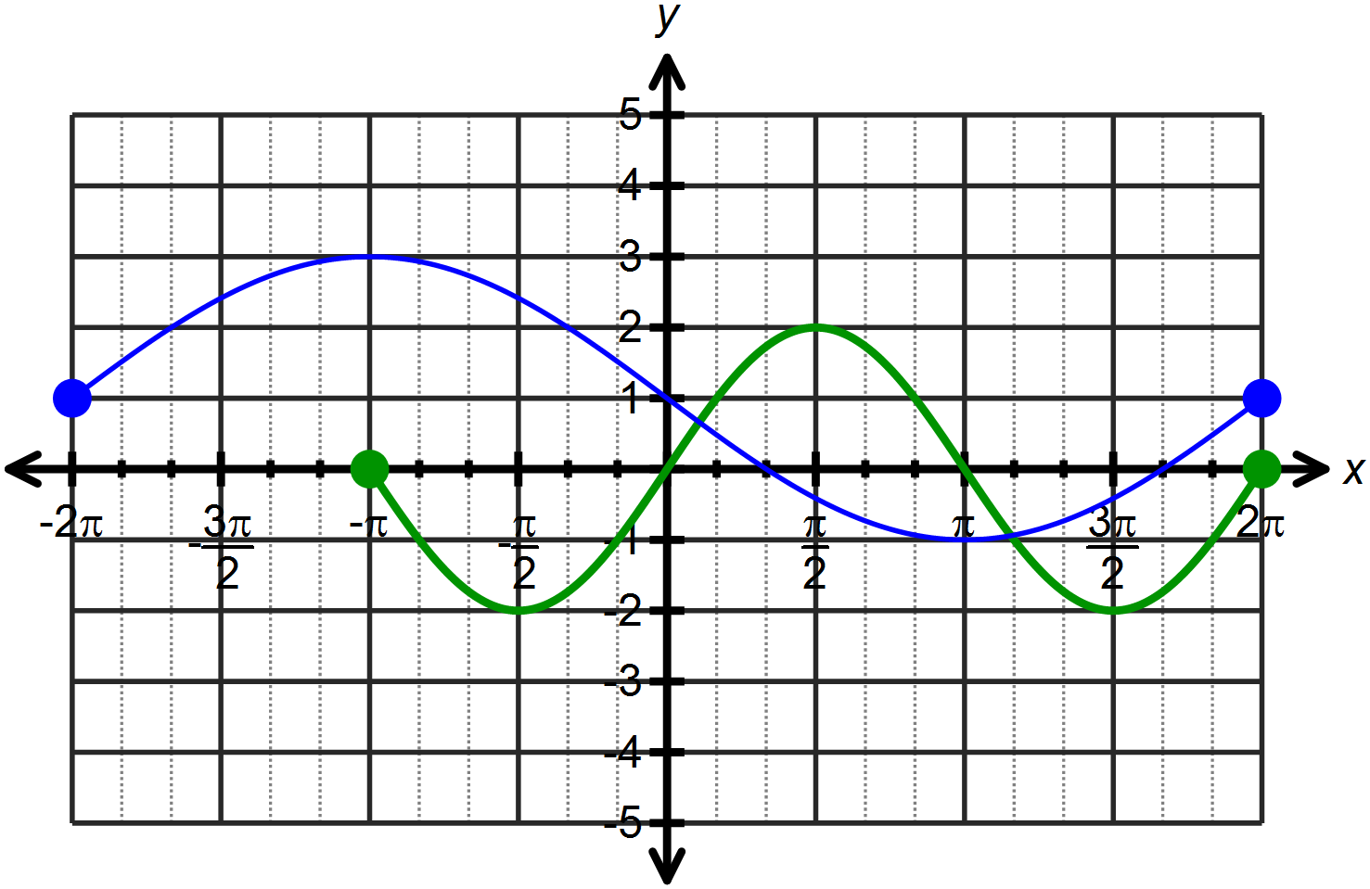







1. State the domain and range of the function drawn.



1. State the roots of the function.





1. State the roots of the function  over the domain 





1. Determine the coordinates of the minimum point(s) of the function over the domain 





1. Sketch  on the axes above, over the domain 

**Question Three: [3 marks]**

In a rural part of Australia, biological scientists are monitoring the populations of wild rabbits and foxes. They have discovered that the population of both species can be modeled by sine functions, where *x* is the time in months since the study began.

The population of foxes is given by: 

The population of rabbits is given by: 

By graphing both functions on your calculator, what do you notice about the population of each species in this rural area?

As the fox population reaches its maximum number, the rabbit population reaches its minimum number. Thus as the rabbit population decreases, the foxes lose their source of food and their population begins to decline as the rabbit population increases again.

**Question Four: [1, 2, 3 = 6 marks]**

A satellite is orbiting the earth and its displacement from the equator is modeled by the following function, where north indicates a positive displacement:



At its furthest point north of the equator the satellite is 600 km away. It takes the satellite 1.5 hours to complete one orbit.

1. Determine the value of *A*  in the model above.



$A=600$

1. Determine the value of , the rate of orbit in radians/hour.





$w=\frac{2π}{1.5}$

$=\frac{4π}{3}$

1. Hence or otherwise provide a sketch of one cycle of the orbit of this satellite.

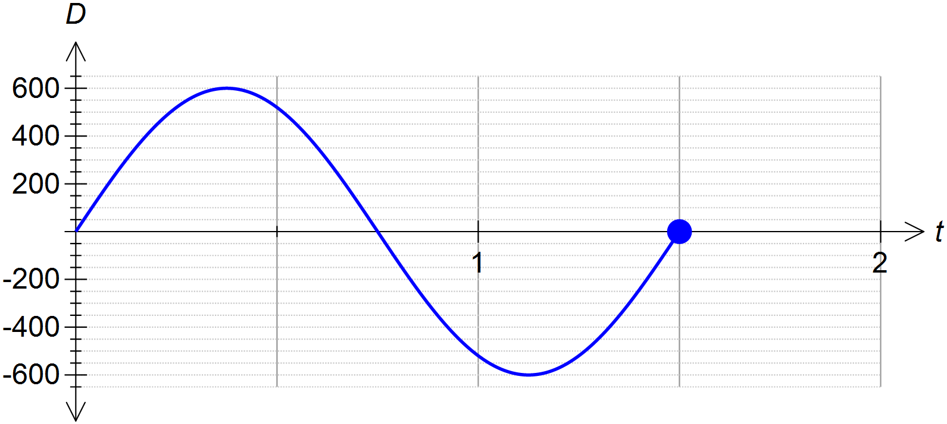

**Question Five: [2, 2, 2, 2, 2 =10 marks]**

The temperature of a healthy human body is about 37˚C.

The temperature of a particular healthy individual is monitored over a 24 hour period and the following information is noted.

Their maximum temperature was 37.1˚C at 11 am.

Their minimum temperature was 36.7˚C at 11 pm.

The temperature of their body can be modeled by:

 where *T* is temperature in ˚C and *t* is the time in hours past midnight.

1. Determine the values of *A* and *B* in the equation.



1. If there is only one maximum and one minimum per day, determine the length of one cycle, and hence the value of *w*.



1. Determine the value of α and hence the equation modeling the temperature for this individual.



1. Over which intervals are the temperatures above 36.8˚C?



1. Express the temperature of this individual as a sine function.



